WIKI-AM,C-Taino-Catalogue-Three-Pointed Stone, Type 1 with reclining figure

WIKI Catalogue Number: F1619.2.T3.TPS1 no.

# Culture: Taino

# Source Location: Dominican Republic

Date: 13th–15th century

Description: Three-Pointed Stone type 1 (TPS1) with reclining figure (also: Three-Cornered Stone, Trigonolito)

Medium: select one: green serpentine, andesite (brown rough), basalt (black rough), sandstone (brown smooth not polished)

Dimensions: H x W x D in. (H x W x D cm.)

Weight: lb. oz. (kg. gm.)

Classification: Stone Sculpture

References:

Fatima Bercht; Ricardo E Alegría. 1998. *Taino: Pre-Colombian Art and Culture from the Caribbean*. Museo del Barrio: New York, NY, p.

# Roberts, Larry; Josh Roberts; Richard Rossetto. [2014] *Taíno sculpture: art of the gods*. Micanopy, FL : Signature Book Printing, p. 70, fig. 110.

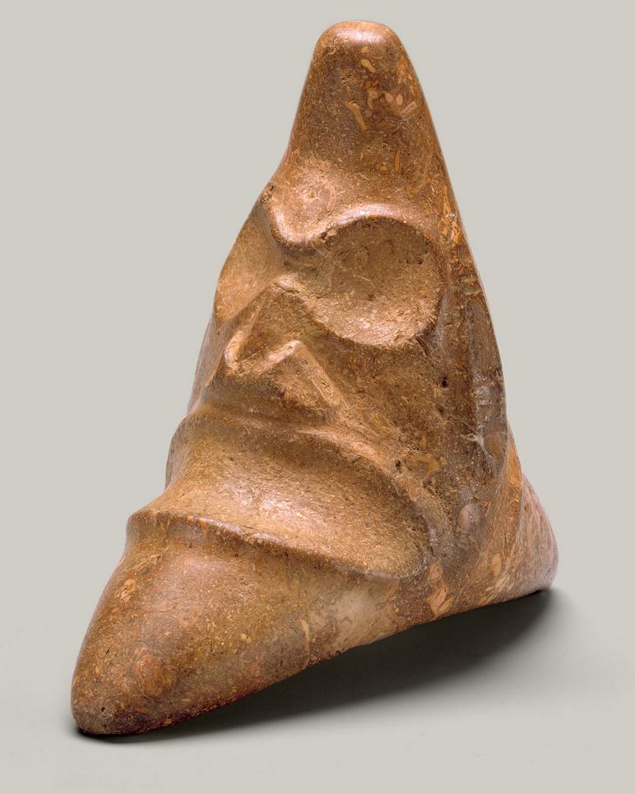Description: The Taino people produced three-cornered stones, known as *trigonolitos*, over a broad expanse of time that allowed for evolution of their form. Early examples are small in size and believed to have been privately owned, while later larger sculptures may have been used in public ceremony. *Trigonolitos* are known in plain and decorated examples, and, as they are concave on the bottom, many do not sit comfortably on a flat surface. A prevalent image among them is that of this compelling face, with large, sunken eye sockets and a wide, toothless mouth. The grimacing face has a skeletal aspect, an imposing quality often found in Taino art. This example bears a pattern of concentric circles on its opposite side, that may represent its power. It was reportedly found in the Dominican Republic, proaly part of one of the major Taino chiefdoms at the end of the fifteenth century. The meaning of much Taino imagery is conjectural, and opinions differ on the *trigonolitos*. Some believe that they are depictions of deities, while others think they are images needed to intercede with deities.